Name:______________________ Date:______________

Directions: You may ONLY use a scientific calculator to complete this test.

Write your answer in the blank provided on the right hand side of the page. Show all work for partial credit.

1. List the intercepts for the equation . 1.______________________
2. Is x3 - 4y4 = 17.09 a function? Explain why or why not.
3. Write the equation of a horizontal line containing (-3,6). 3._______________
4. Find  for the equation . 4.______________
5. Find if and . 5._______________
6. Find the domain of . 6._______________
7. Find  when and . 7.______________
8. Refer to the graph below. Over what interval(s) is f(x)>0? Write your answer in interval notation.

8.______________

y

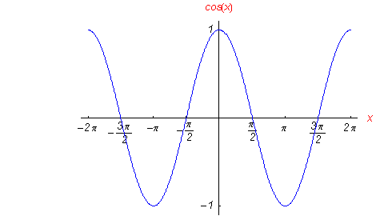

1. Refer to the graph above. Where is f(x) increasing? Write your answer in interval notation. 9._______________
2. Find the y-intercept of . Write the answer as an ordered pair. 10._______________
3. Is  on ? Support your answer. 11._______________

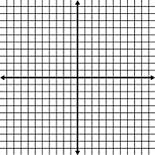

1. Graph 
2. Graph  14. Graph  15. Graph 







Domain: Domain: Domain:

Range: Range: Range:

1. Find the vertical, horizontal, and oblique asymptotes of .
2. Synthetically divide to find if  is a factor of . Explain why or why not using the Factor Theorem.
3. Write a polynomial function of degree 5 that has the following zeros: -3, 1 (multiplicity 2), and 3-2i. Make certain that your answer only has real numbers.